MLKMC Electronic Healthcare System  
System Design Document

**Date:** 30-Oct-2010  
**Project Manager:** Ryan Olson  
**Team:** Tyler Bradovich, Cameron Harp, Matthew Kimber, Ryan Olson  
**Sponsor:** Prof. Richard Fry  
**Client:** Martin Luther King Memorial Clinic  
**Website:** http://kaizen.matthewkimber.com/

Table of Contents

Introduction 3

Class Diagram and Interface Specification 3

Class Diagram 3

Data Types and Operation Signatures 4

System Architecture and System Design 10

Architectural Styles 10

Identifying Subsystems 11

Mapping Subsystems to Hardware 11

Persistent Data Storage 12

Network Protocol 12

Global Control Flow 13

Hardware Requirements 14

Software Requirements 15

Algorithms and Data Structures 16

Algorithms 16

Data Structures 19

User Interface 20

Appointment Scheduling 21

Login 22

Administrator - Create User 24

Administrator – View/Edit Users 25

Pharmacy Inventory Management 26

Clinic Supplies Inventory Management 27

Progress Report 28

Responsibility Breakdown 28

Plan of Work 28

Contributions Breakdown 31

Works Cited 32

Introduction

The Electronic Healthcare System (EHS) will be composed of the following classes and system architecture design. These requirements have been derived from the SSRS document and the new information we have received from Dr. Duah. Any new information gathered may cause further expansion or modification as we discover more requirements of the system.

Class Diagram and Interface Specification

Class Diagram



Data Types and Operation Signatures

***Patient* Class:**



***PatientRepository* Class:**



***Encounter* Class:**



***Appointment* Class:**



***AppointmentRepository* Class:**



***Medication* Class:**



***MedicationRepository* Class:**



***Prescription* Class:**



***Physician* Class:**



***Nurse* Class:**



***Receptionist* Class:**



***Symptom* Class:**



***SymptomRepository* Class:**



System Architecture and System Design

Architectural Styles

The MLKMC-EHS will be built using a service-oriented, n-tier architecture. Multiple client computers will connect to a local server, which will provide well-defined services for each client. These services will typically be composed of methods for retrieving data from, and changing data in the database. Client computers “consume” a service by using what looks just like a method call. For example, a client might need all the medical records for a particular patient. To do this, the client code basically performs a method call on the service, providing the Patient as a parameter, and the service returns the medical records.

The system will also be separated into different layers or tiers, “*n*” being the number of tiers in our *n*-tier architecture. Presentation/UI, services, domain/business logic, and data access code will reside in separate classes. Keeping these separate allows for better organization, and easier modification to any single tier. Group members can work on separate tiers at the same time and not conflict with each other.

Identifying Subsystems

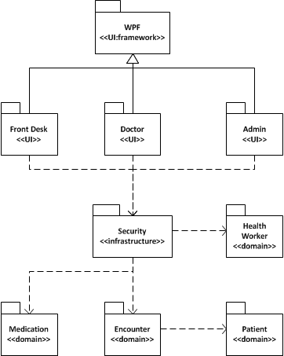

The MLKMC-EHS system is divided into subsystems as pictured above. There are three distinct user interface packages, each containing a set of files and resources to allow user interaction. Domain packages contain all other classes for the system, with closely related classes grouped together.

Mapping Subsystems to Hardware

The user interface modules will run on separate computers from the non-interface modules. The Front Desk UI will run only on clients at the front desk. The Doctor and Admin user interface subsystems will run on computers located in doctor’s offices. All other domain modules will run on a local server computer, which can be accessed by any of the client computers.

Persistent Data Storage



Network Protocol

We will be using the Windows Communication Foundation (WCF) to distribute the system over multiple computers. A central server will host the application, which will provide each client with services in order to access and modify central data. By using WCF and having it on a central server it will allow for updates to be easily pushed out to all computers on the network, minimizing having to update every computer individually.

The following diagram from andrewtokely.net describes the WCF architecture and organization.

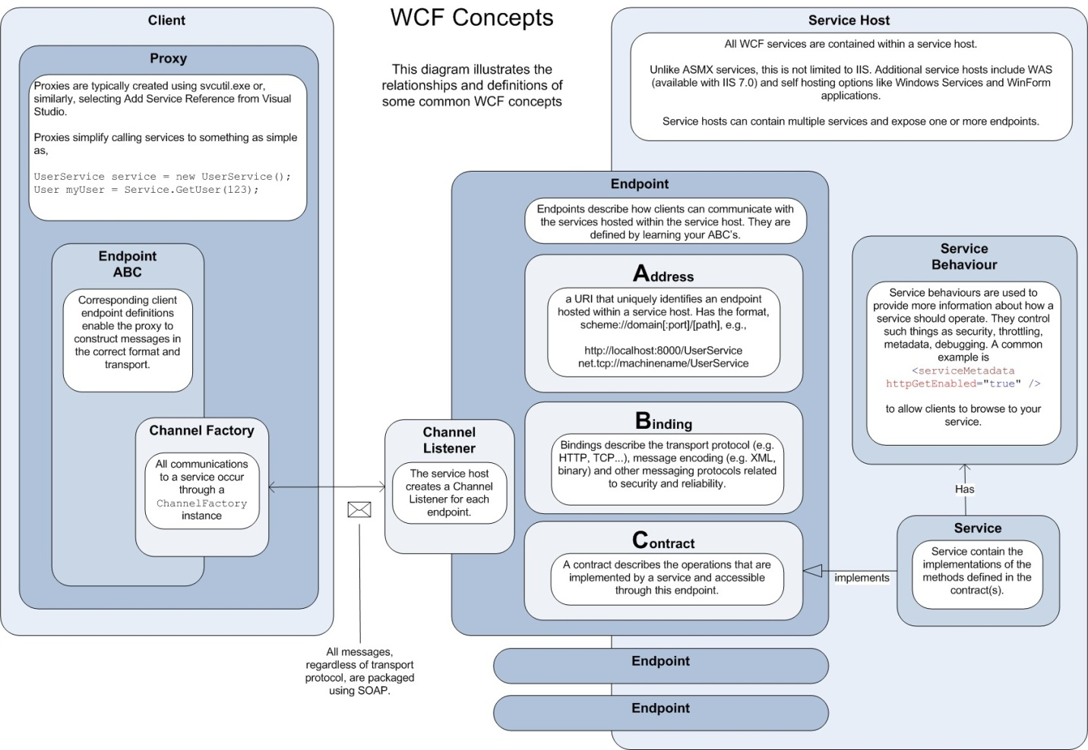

(Tokely)

Global Control Flow

**Execution Order**

The system will be event-driven via a graphical user interface. Users will be able to generate actions in different orders by clicking different command buttons. The system will then respond to that event in an appropriate manner that we define.

**Time Dependency**

The system will be of the event-response type, with no concerns for real time. Various weekly reports will be generated however, using a date-time mechanism to generate a weekly event.

**Concurrency**

The methodology for handling concurrency will be optimistic concurrency. The environment in which the system will be installed has a low contention for data and therefore the need for a pessimistic concurrency model is unnecessary. However, this approach will be evaluated as testing and integration occurs.

Hardware Requirements

The MLKMC-EHS will consist of one computer at the front desk, three computers for the physician’s offices, and a computer acting as a local server. These computers will be networked using standard CAT-5 cable. Each computer will need a monitor with a resolution of *at least* 1024 x 768 pixels. In summary, the hardware requirements for the system include the following minimal setup:

* Server System
  + 1.6 GHz+ processor.
  + 512 MB of RAM.
  + 25 GB of unused hard drive space.
  + 100 Mbps network adapter
  + Monitor supporting a resolution of 1024 x 768.
* Client Systems
  + 1.6 GHz+ processor.
  + 512 MB of RAM.
  + 2 GB of unused hard drive space.
  + 100 Mbps network adapter.
  + DirectX 9 capable video card.
  + Monitor supporting a resolution of 1024 x 768.

Common hardware that is required for the system will include:

* One router for DHCP.
* Zero to one switches.
* CAT-5 cabling.
* One or more printers.
* One laser barcode scanner.

Software Requirements

Various software packages will need to be installed on the hardware that comprises the system. The following items are dependencies of the system to be developed and required in order to run properly:

* Server
  + Microsoft Windows XP or greater.
  + Microsoft .NET Framework 4.0 or greater.
  + MySQL Community Server 5.1+
* Client
  + Microsoft Windows XP or greater.
  + Microsoft .NET Framework 4.0 or greater.

Algorithms and Data Structures

Algorithms

**Inventory System:**



**Printer System:**



**Scanner System:**



**Sequence Diagram Reports:**



Data Structures

Various data structures will be used within the MLKMC-EHS most of which are derivatives of data structures already implemented in the Microsoft .NET Framework. These data structures include the following:

* List<T>
* ObservableCollection<T>
* Dictionary<TKey, TValue>
* SortedDictionary<TKey, TValue>
* HashSet<T>
* As well as classes that implement the IEnumerable<T> interface.

For now these data structures will be the only data structures used in the implementation. However, custom data structures may be implemented in the future and will be fully documented here.

User Interface

The initial screen mock-ups developed for *Report #1* have been modified in the following ways:

1. New method of working with appointment scheduling.
2. Login mock-ups created.
3. Administrative capabilities mock-ups created.
4. Mock-up created for pharmacy inventory management.
5. Mock-up created for clinic supply inventory management.

Appointment Scheduling

Instead of the clerk clicking *Appointments,* then clicking *View Appointments* or *Make Appointment*, all the appointment functionality will be available from the home screen for the front desk. It is easy for the clerk to see upcoming appointments, and when each doctor has an opening for a new appointment. From this home screen, existing appointments can be easily canceled or rescheduled by right clicking the appointment block, or by drag and drop to reschedule. This is a significant improvement in ease of use over the old scheduling design.

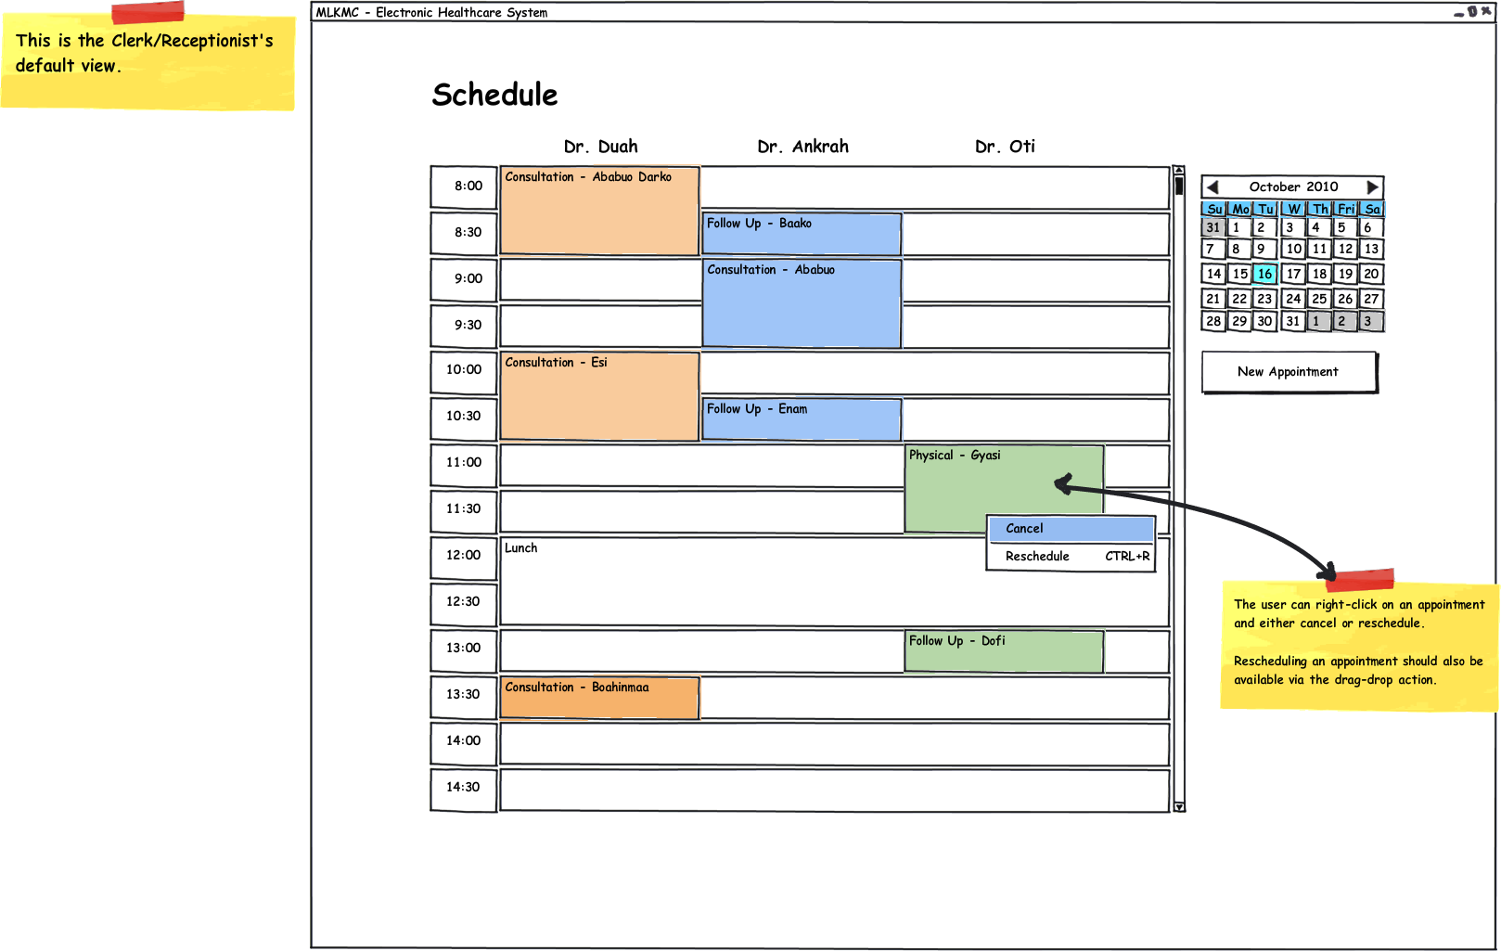

Login

To be able to use the system, every user must log-in with a unique username and a password. These usernames and passwords can be managed by a user with administrative privileges for the system.

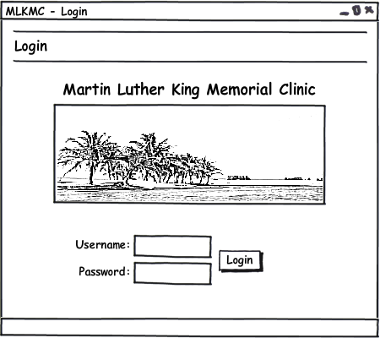

1. Enter a username (case-insensitive) and a password (case-sensitive).
2. Click “Login” to submit the username and password.

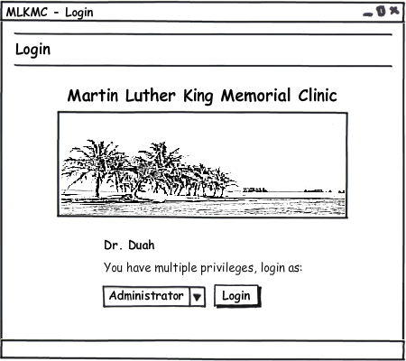

1. If a user has multiple privileges for the system, such as Doctor and Administrator, then the options above will be presented.
2. Choose a login type from the drop-down list.
3. Click “Login” to enter the system under the chosen role view.

Administrator - Create User

Only users with administrative rights can create new users for the system.

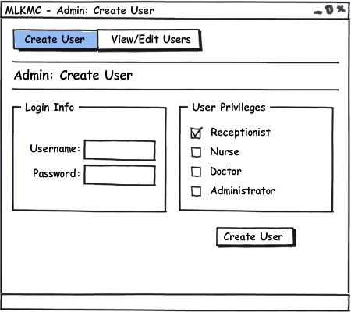

1. Click the “Create User” tab from the menu bar if not already selected.
2. Enter the desired username and password of the new user.
3. Choose at least one user privilege to define what system functions the user may perform.

Administrator – View/Edit Users

Users with administrative rights can view and edit information for other system users.

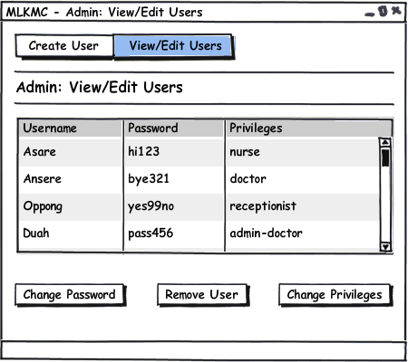

1. Click the “View/Edit Users” tab from the menu bar.
2. Select a user from the list by clicking the row that contains their username.
3. Click one of the three buttons to perform the action on the selected user.

Pharmacy Inventory Management

The pharmacy inventory can be viewed, adjusted, and managed using the MLKMC system.

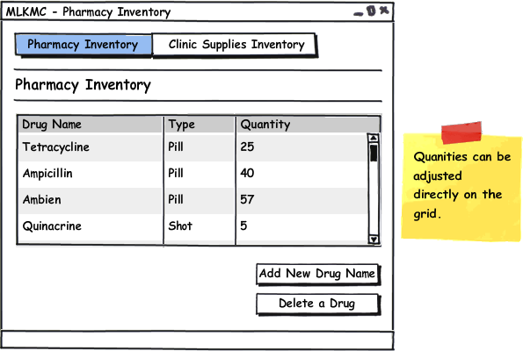

1. Click the “Pharmacy Inventory” tab if not already selected.
2. Click inside any quantity field and type a new quantity to adjust its value.
3. Click “Add New Drug Name” or “Delete a Drug” to add/delete entire items on the list.

Clinic Supplies Inventory Management

The clinic supplies inventory can be viewed, adjusted, and managed using the MLKMC system.

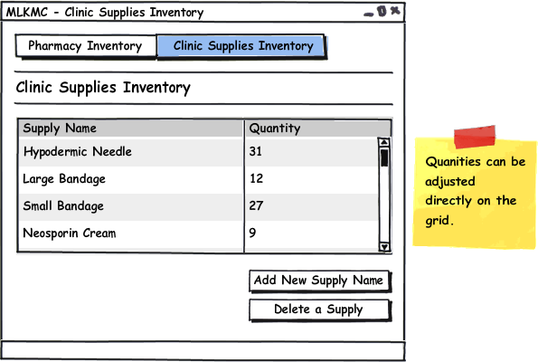

1. Click the “Clinic Supplies Inventory” tab from the menu bar.
2. Click inside any quantity field and type a new quantity to adjust its value.
3. Click “Add New Supply Name” or “Delete a Supply” to add/delete entire items on the list.

Progress Report

Currently, we have implemented several key components of our project. Some include the following: Patient operations (edit, create, search and delete) and Appointment operations (schedule view, edit, create and search by day.

Responsibility Breakdown

|  |  |  |  |  |
| --- | --- | --- | --- | --- |
| ***Modules*** | **Ryan** | **Tyler** | **Matt** | **Cameron** |
| **Data Tier** | 65% | 5% | 10% | 20% |
| Repositories | 80% | 0% | 10% | 10% |
| UnitOfWork | 80% | 0% | 10% | 10% |
| Database | 0% | 0% | 10% | 90% |
| **Domain Tier** | 30% | 30% | 10% | 65% |
| **Services Tier** | 25% | 25% | 25% | 25% |
| **Presentation Tier** | 5% | 20% | 65% | 0% |

History of Work

|  |  |  |  |  |
| --- | --- | --- | --- | --- |
| Task Name | Duration | Start | Finish | Predecessors |
| **Analysis/Software Requirements** | **4.53 days?** | **Wed 9/1/10** | **Tue 9/7/10** |  |
| Conduct needs elicitation and analysis | 10 hrs | Wed 9/1/10 | Thu 9/2/10 |  |
| Draft preliminary software specifications | 10 hrs | Thu 9/2/10 | Fri 9/3/10 | 2 |
| Develop delivery timeline | 2 hrs | Mon 9/6/10 | Mon 9/6/10 | 2,3,5 |
| Review software specifications | 0.5 hrs | Fri 9/3/10 | Fri 9/3/10 | 3 |
| Obtain approval to proceed | 0.25 hrs | Tue 9/7/10 | Tue 9/7/10 | 2,3,4,5 |
| Analysis Complete | 0 days | Tue 9/7/10 | Tue 9/7/10 | 6 |
|  |  |  |  |  |
| **Design** | **55 days** | **Mon 9/20/10** | **Mon 12/6/10** | **1** |
| Review software specifications | 2 hrs | Mon 9/20/10 | Mon 9/20/10 |  |
| Decide on SRS template | 0.5 hrs | Mon 9/20/10 | Mon 9/20/10 | 10 |
| Develop functional specifications | 2 hrs | Tue 9/28/10 | Tue 9/28/10 | 11 |
| Develop nonfunctional specifications | 2 hrs | Tue 9/28/10 | Tue 9/28/10 | 11 |
| Develop prototype based on functional requirements | 10 hrs | Tue 9/28/10 | Wed 9/29/10 | 12,13,17,18,19 |
| Review functional specifications | 2 hrs | Wed 9/29/10 | Wed 9/29/10 | 12,13 |
| Determine plan of work | 1 hr | Mon 9/20/10 | Mon 9/20/10 | 11 |
| Develop use cases | 4 hrs | Mon 9/20/10 | Mon 9/20/10 | 10 |
| Develop use case specifications | 1 hr | Tue 9/21/10 | Tue 9/21/10 | 17 |
| Design UI Mockups | 10 hrs | Mon 9/20/10 | Tue 9/21/10 | 10 |
| Fill out contributions breakdown | 1 hr | Tue 9/21/10 | Tue 9/21/10 | 18 |
| Report #1 (First draft) | 0 days | Sat 10/2/10 | Sat 10/2/10 |  |
| Schedule meeting | 0.5 hrs | Mon 10/4/10 | Mon 10/4/10 | 21 |
| Meeting with fry | 0.5 hrs | Wed 10/6/10 | Wed 10/6/10 | 22 |
| Edit as specified from meeting | 10 hrs | Wed 10/6/10 | Thu 10/7/10 | 23 |
| Report #1 (Final) | 0 days | Sat 10/16/10 | Sat 10/16/10 | 24 |
| Decide on SSD template | 0.5 hrs | Mon 10/18/10 | Mon 10/18/10 | 25 |
| Determine interface specification | 1 hr | Mon 10/18/10 | Mon 10/18/10 | 26 |
| Design architecture | 3 hrs | Mon 10/18/10 | Mon 10/18/10 | 25 |
| Design UML | 10 hrs | Mon 10/18/10 | Tue 10/19/10 | 25 |
| Define our algorithms and data structures | 1 hr | Mon 10/18/10 | Mon 10/18/10 | 26 |
| Decide how we are going to network the computers | 1 hr | Mon 10/18/10 | Mon 10/18/10 | 25 |
| Create progress report | 2 hrs | Mon 10/18/10 | Mon 10/18/10 | 30 |
| Hardware requirements | 1 hr | Mon 10/18/10 | Mon 10/18/10 | 26 |
| Design database ERD | 10 hrs | Mon 10/18/10 | Tue 10/19/10 | 25 |
| Report #2 | 0 days | Sat 10/30/10 | Sat 10/30/10 | 34,33,32,31,30,29,28 |
| Prepare for Demo #1 (slides, script, etc.) | 2 hrs | Mon 11/15/10 | Mon 11/15/10 |  |
| Prepare program for in class demonstration | 2 hrs | Mon 11/15/10 | Mon 11/15/10 |  |
| Obtain approvals to proceed | 0.25 hrs | Mon 11/15/10 | Mon 11/15/10 | 36,37,38 |
| Demo #1 | 0 days | Sat 11/20/10 | Sat 11/20/10 | 35 |
| Edit report #1 and report #2 and merge them | 2 hrs | Mon 11/22/10 | Mon 11/22/10 |  |
| Add history of work and current status | 0.5 hrs | Wed 11/24/10 | Wed 11/24/10 |  |
| Add conclusions and plan for future work | 0.5 hrs | Wed 11/24/10 | Wed 11/24/10 |  |
| Generate references that were used in our project | 0.5 hrs | Wed 11/24/10 | Wed 11/24/10 |  |
| Get client to sign it off | 0.25 hrs | Wed 11/24/10 | Wed 11/24/10 | 41,42,43,44 |
| Report #3 | 0 days | Mon 12/6/10 | Mon 12/6/10 | 45 |
| Design Complete | 0 days | Mon 12/6/10 | Mon 12/6/10 | 46 |
| **Development** | **13 days** | **Sun 1/3/10** | **Thu 1/21/10** | **9** |
| **Testing** | **18.63 days** | **Wed 1/5/11** | **Mon 1/31/11** | **48** |
| **Training** | **3.5 days** | **Wed 2/2/11** | **Mon 2/7/11** | **56** |
| **Documentation** | **14.31 days** | **Wed 2/9/11** | **Tue 3/1/11** | **73** |
| **Pilot** | **6.88 days** | **Mon 3/7/11** | **Tue 3/15/11** | **81** |
| **Deployment** | **20 days** | **Sun 2/20/11** | **Sat 3/19/11** | **91** |
| **Post Implementation Review** | **1.13 days** | **Wed 4/27/11** | **Thu 4/28/11** | **98** |
| SDLC complete | 0 days | Thu 4/28/11 | Thu 4/28/11 | 109 |
|  |  |  |  |  |

Contributions Breakdown

|  |  |  |  |  |  |
| --- | --- | --- | --- | --- | --- |
| ***Tasks*** | **Ryan** | **Tyler** | **Matt** | **Cameron** | ***Allocation*** |
| Project Management | 100% | 0% | 0% | 0% | 100% |
| Interaction Diagrams | 15% | 15% | 15% | 55% | 100% |
| Class Diagrams and Specs | 15% | 25% | 35% | 25% | 100% |
| System Architecture and Design | 10% | 15% | 60% | 15% | 100% |
| Network Protocol | 10% | 40% | 25% | 25% | 100% |
| ERD Diagrams | 0% | 0% | 50% | 50% | 100% |
| User Interface Design | 10% | 75% | 15% | 0% | 100% |
| Plan of Work | 40% | 20% | 20% | 20% | 100% |
| References | 25% | 25% | 25% | 25% | 100% |
| **Possible Points** | *22.5* | *21.85* | *26.55* | *30.1* |  |
| |  | | --- | |  | |  |  |  |  |  |
|  |  |  |  |  |  |
|  |  |  |  |  |  |
|  |  |  |  |  |  |
|  |  |  |  |  |  |
|  |  |  |  |  |  |
|  |  |  |  |  |  |
|  |  |  |  |  |  |
|  |  |  |  |  |  |
|  |  |  |  |  |  |
|  |  |  |  |  |  |
|  |  |  |  |  |  |
|  |  |  |  |  |  |
|  |  |  |  |  |  |
|  |  |  |  |  |  |
|  |  |  |  |  |  |
|  |  |  |  |  |  |
|  |  |  |  |  |  |
|  |  |  |  |  |  |
|  |  |  |  |  |  |
|  |  |  |  |  |  |

Summary of Changes

* Added history of work
* Revised progress report to the latest progress

# **Works Cited**

Evans, Eric. Domain-Driven Design. Boston: Addison-Wesley, 2004.

Fowler, Martin. Patterns of Enterprise Application Architecture. Boston: Addison-Wesley, 2003.

Kuaté, Pierre Henri, et al. NHibernate in Action. Greenwich: Manning, 2009.

Tokely, Andrew. Thoughts on the Software Development Industry. 31 July 2008. 22 October 2010 <http://andrewtokeley.net/archive/2008/07/31/wcf-simplified-to-a-single-diagram.aspx>.